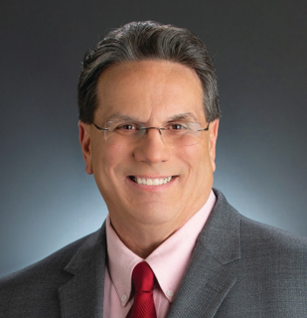

Bruce E Phipps CPP

Senior Principal Product Manager, US Legislation

ORACLE

Immediate Past President – PayrollOrg
2011 PayrollOrg, Payroll Man of the Year.

In his current role at Oracle, Bruce is responsible for the US Legislative requirement for the cloudbased payroll products.
Bruce has been employed in the payroll profession for 45 years and has worked for several employers in the following industries, Healthcare, Retail, Service industries, Television Retailers and Manufacturing. During his career, he has served as a key member for several system upgrades/implementations and mergers/acquisitions.

Bruce has held his CPP designation since 1989. He currently serves on the following APA committees: Hotline Referral, Electronic Payments Committee, GRTF - Pay Card Sub Committee, Child Support and Garnishment Sub Committee, Co-Chair PA Act 32 Sub Committee, Emerging Technologies - SPLTF, Champs Mentor, Social Networking, Education Grant Committee and National Speakers Bureau.
Additionally, Bruce is one of the original co-authors to the first edition of APA’s “A Successful Guide to Direct Deposit”

Bruce has been a Congress speaker since 2004 and the Texas Payroll Conference since 2006 and frequently speaks at chapter meetings and State wide Conferences. Bruce Speaks on a wide range of topics, primarily though his specialty is State and Local incomes taxes.

Bruce is currently the Treasurer of the Southeastern Pa Chapter of the APA. Bruce was also one of the founding members of the Southeastern PA Chapter of the APA and served as the chapter’s first president. Spanning 18 years as a member of the SEPA chapter Bruce held several officer positions.

Serving as an officer of a local chapter, provides an opportunity to promote the payroll profession throughout Pennsylvania and surrounding states.

